Project on Temperature Display and Warning

CODE BREAKDOWN

This project uses DS18B20 1-Wire Temperature sensor and A standard 16x2 LCD display
We are using 3 external libraries
- LiquidCrystal: its a simple library which helps us print texts on the LCD Display
- DallasTemperature: Since the DS18B20 uses a 1 wire communication protocol we use this library to make things simpler
- OneWire: Since arduino has no in build support for 1 wire protocol, it knows how to send bits on the wire with correct timing

Next we define which pin is connected to sensor’s data pin using #define. Now
we create a OneWire object and tell it which pin the sensor is connected to then we create a DallasTemperature object and pass it the reference to the OneWire object we just created.

“LiquidCrystal lcd(7, 5, 10, 11, 12, 13);” the first pin corresponds to RS next one E of the LCD, and last 4 are data pins

In void main()
We define the size of lcd, then define a pinmode for pin 2 to get a output which can light the led then we clear the lcd.

In void loop()
Now we get the temperature reading using data pin the store it in a floating variable temp and print it for reference. We now move the cursor to 2nd line and print temp on the LCD.
Then apply if conditions with 60 as threshold temperature, for more than 60 Celsius the LED glows and it stays dim for temperature less than 60.

CONNECTION BREAKDOWN

5v supply is connected to top row of bread board and ground is connected to bottom row. The data pin of DS18B20 is connected to pin 4, the vcc and gnn are connected to 5v line and ground respectively.

The Led is connected in series to the 5v supply line along with a 330 ohm resistor so that it doesnt burn out instantly after we switch on the circuit.

As for the LCD screen, the 15 and 16th pins are anode and cathode which power the LCD they are connected to 5v supply line and ground respectively. Again the 1st pin is GND and 2nd pin is VCC which is connected to 5v supply.Since we are connecting the screen in 4 bit mode, data pins from D4 to D7 are connected to 10 to 13 pins of the arduino. The E pin of LCD tell the screen when to accept data, it goes from HIGH to LOW and tell it when to take data, this is connected to pin 5.

To be honest u can use the 8bit mode which transfers data at a faster rate but requires 8 data pins, for easier circuit design and to reduce complexity of the circuit i have used the 4bit mode which is enough for this scenario.

(NEXT PAGE)

(NEXT PAGE)

(NEXT PAGE)

(NEXT PAGE)

Temperature below 60 Celsius
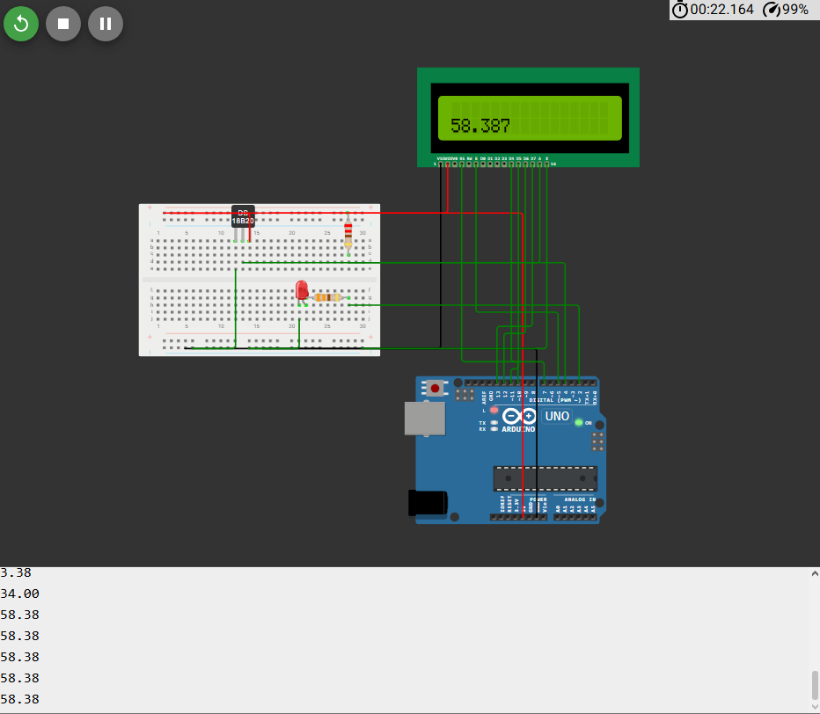

Temperature above 60 Celsius
